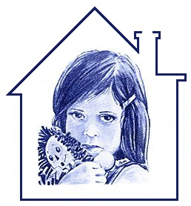
August, 2015
Dear Friend and Suppor Hibiscus Children’s Center
Saving Children Since 1985

26th Annual
Jo Covelli Fashion Show and Luncheon

Grand Benefactor

Jo Covelli

Chair and Co-Chair

Heidi Monsour
Nancy Ritter

Committee Members

Kelly Bennin
Ashley Braden-Knowles
Andi Brennan
Ellie Lafer
Pam Gardner
Cynthia Goings
Molly Hoffman
Barbara James
Chris Kruth
Joyce Powell
Sharon Rodger
LaVaug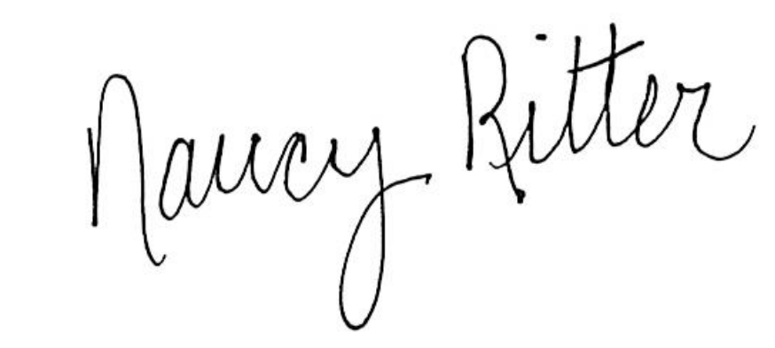hn Tilton
Judie Wolfe
Mary Zottoli
Hibiscus Children’s Center
Saving Children Since 1985

26th Annual
Jo Covelli Fashion Show and Luncheon

Grand Benefactor

Jo Covelli

Chair and Co-Chair

Heidi Monsour
Nancy Ritter

Committee Members

Kelly Bennin
Ashley Braden-Knowles
Andi Brennan
Ellie Lafer
Pam Gardner
Cynthia Goings
Molly Hoffman
Barbara James
Chris Kruth
Joyce Powell
Sharon Rodger
LaVaughn Tilton
Judie Wolfe
Mary Zottoli
Hibiscus Children’s Center
Saving Children Since 1985

26th Annual
Jo Covelli Fashion Show and Luncheon

Grand Benefactor

Jo Covelli

Chair and Co-Chair

Heidi Monsour
Nancy Ritter

Committee Members

Kelly Bennin
Ashley Braden-Knowles
Andi Brennan
Ellie Lafer
Pam Gardner
Cynthia Goings
Molly Hoffman
Barbara James
Chris Kruth
Joyce Powell
Sharon Rodger
LaVaughn Tilton
Judie Wolfe
Mary Zottoli
Hibiscus Children’s Center
Saving Children Since 1985

26th Annual
Jo Covelli Fashion Show and Luncheon

Grand Benefactor

Jo Covelli

Chair and Co-Chair

Heidi Monsour
Nancy Ritter

Committee Members

Kelly Bennin
Ashley Braden-Knowles
Andi Brennan
Ellie Lafer
Pam Gardner
Cynthia Goings
Molly Hoffman
Barbara James
Chris Kruth
Joyce Powell
Sharon Rodger
LaVaughn Tilton
Judie Wolfe
Mary Zottoli
ter of Hibiscus,
Hibiscus Children’s Center is a nationally accredited, not-for-profit organization serving children and families on the Tre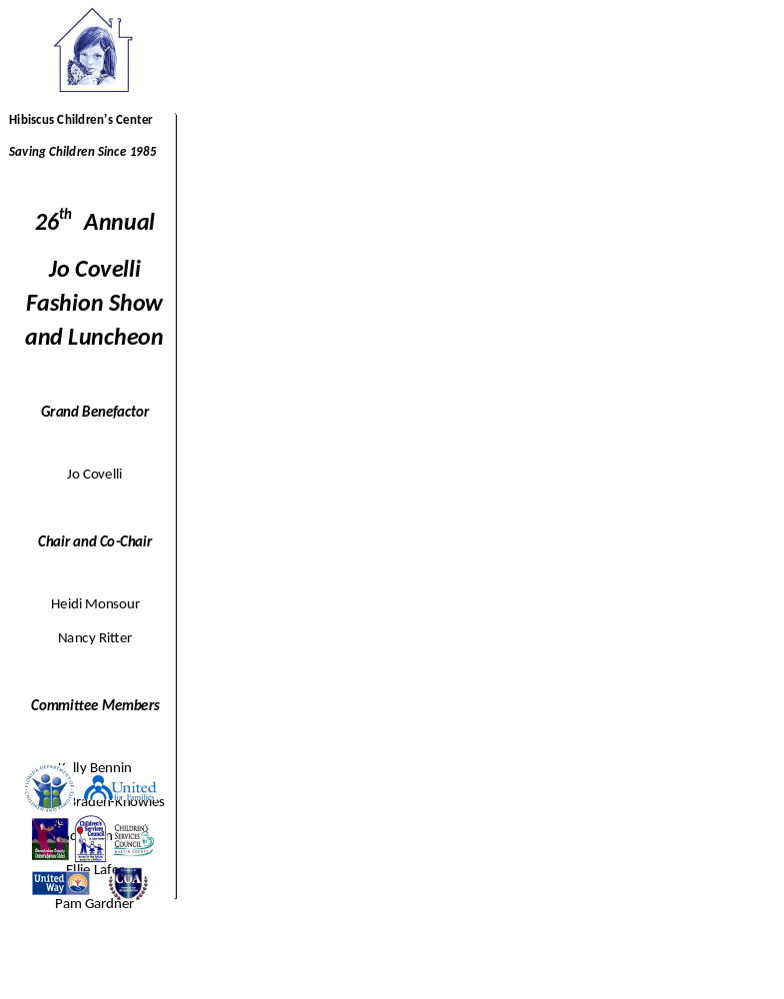asure Coast and throughout Florida. For 30 years, the mission of Hibiscus Children’s Center has been to save abused children and since its’ inception in 1985, Hibiscus Children’s Center has provided more than 250,000 safe nights to abused, neglected and abandoned children in our communities. Our programs provide Residential, Medical, Psychological and Educational services focusing on prevention, intervention and recovery services. Hibiscus Children’s Center operates around the clock - 24 hours a day, 7 days a week, 365 days a year!
The Hibiscus Children’s Center 25th Annual Jo Covelli Fashion Show and Luncheon will be held Monday, March 7, 2016 at the prestigious Sailfish Point Country Club. This premier event brings together over 250 concerned citizens every year to champion against child abuse and raise the necessary funds for the Hibiscus Children’s Center to operate. The support of local businesses is essential to the success of this event! Please consider which of the following ways you would like to participate;
Live Auction Item Donation: The 25th Annual Jo Covelli Fashion Show and Luncheon will feature a Live Auction featuring a maximum of five high value lots. These premier items and their donors will be announced in event press releases, receive recognition in the event program and be promoted live during the event.
Silent Auction Item Donation: In-kind donations from businesses and individuals will be used to create a variety of gift baskets for the Silent Auction at the 25th Annual Jo Covelli Fashion Show and Luncheon. We invite you to promote your business to our attendees by providing new merchandise or gift certificate(s). No item is too large or too small. All donors will be featured on auction signage and recognized in the event program.
“Swag” Bag Contributions: Donors are also invited to market your products and/or services through a contribution of 250 promotional items, gift cards and/or coupons that will be shared with our fashion show attendees as a thank you for their volunteer and financial support to Hibiscus.
By making an in-kind donation to this event, you are helping to rebuild and repair the shattered lives of abused children in our communities. If you would like more information or if you would like to discuss further opportunities to support Hibiscus Children’s Center, please contact me at 772-349-1523 or heidimonsour@comcast.net
On behalf of the children thank you for your support!

Heidi Monsour
Event Chair


Dear Cherished Friend of Hibiscus,

Since 1989, Hibiscus Children's Center has stood unwavering in its commitment to be a sanctuary of hope, a guiding light towards healing, and a nurturing force for children who have faced the harshest of trials – abuse, neglect, and abandonment. We believe in a brighter tomorrow, a place where these resilient young souls can find courage, love, safety, and trust.

As a devoted supporter and a beacon of hope for these children, we extend to you a heartfelt invitation to embark on an extraordinary journey with us. Join us on the 4th of March 2024, for the 31st Annual Jo Covelli Luncheon, this year with a whimsical theme – "Follow The Yellow Brick Road."

We extend our deepest gratitude to our incredible Grand Benefactor, Jo Covelli, whose unyielding dedication has been a steadfast source of strength for the children we serve.

Our Co-Chairs, Diana Baker and Sally Batz, along with their dedicated committee have orchestrated a day filled with joy and wonder, designed to make your heart sing. So, dust off your favorite hat, a symbol of honor for the children we support, and prepare for a delightful luncheon, a captivating silent auction (with beautiful artwork donated by local artists and the children themselves), fantastic raffle baskets, and a small marketplace buzzing with exciting vendors.

We're thrilled to bring back our very special guest, Daryl Magill, a gifted singer, entertainer, and concert producer.

Your support is the magic wand that helps these children
"Follow their dreams Over The Rainbow".

You, dear friend, are an integral part of the heartwarming success of our Jo Covelli Luncheon each year. In 2024, more than ever, we need your help. We offer a variety of sponsorship opportunities, and we're ready to tailor your support to suit your needs perfectly. For more details, please reach out to Lori Swift, our Director of Outreach and Events, at LSwift@HCC4kids.org or 772-634-1312.

From our hearts, we thank you. We eagerly anticipate your presence on March 4th, as we come together to create a brighter future for these remarkable children.


Please return this portion in the self-addressed stamped envelope provided.

_____________________________________________________________________________________
(Your name and how it should appear in recognition materials)

Over the Rainbow $10,000 - 8 tickets included Payment and Credit Card Information:
Wizard of Oz $ 5,000 - 6 tickets included ◻ Payment enclosed
Dorothy $ 2,500 - 4 tickets included ◻ Please charge my credit card
Ruby Slipper $ 1,500 - 2 tickets included. ◻ I cannot attend, please accept my donation of:
$_______________
Additional Sponsorship Levels ◻ Yes, I would like to help with the 5% processing fee
Tickets Not Included ◻Visa ◻MasterCard ◻American Exp. ◻Discover
Tin Man $ 1,000 Credit Card #________________________________
Scarecrow $ 500 Exp. Date ________________ Security Code ______
Lion $ 250 Name on Card _______________________________
Toto $ 125 Address ____________________________________
Phone ________________Email____________________


27th Annual
Jo Covelli Fashion Show and Luncheon

Grand Benefactor

Jo Covelli

Committee Members

Ashley Braden-Knowles
Andi Brennan
Pam Dallas
Pam Gardner
Molly Hoffman
Ellen Houts
Chris Kruth
Ellie Lafer
Daryl Magill
France Pfeifle
Joyce Powell
Sharon Rodger
LaVaughn Tilton
Judie Wolfe
Mary Zottoli

27th Annual
Jo Covelli Fashion Show and Luncheon

Grand Benefactor

Jo Covelli

Committee Members

Ashley Braden-Knowles
Andi Brennan
Pam Dallas
Pam Gardner
Molly Hoffman
Ellen Houts
Chris Kruth
Ellie Lafer
Daryl Magill
France Pfeifle
Joyce Powell
Sharon Rodger
LaVaughn Tilton
Judie Wolfe
Mary Zottoli

31^{ST ANNUAL}
Jo Covelli Luncheon

Grand Benefactor
Jo Covelli

Event
Co-Chairs
Diana Baker
Sally Batz

Committee Members
Dana Anderwald
Andi Brennan
Amy Freese
Pam Gardner
Jill Hanson
Molly Hoffman
Ellie Lafer
Toni MacDonald
JoAnn Munro
Rita Nelson
Deb Owen
Terri Pettengill
Joyce Powell
Bonnie Schamback
Linda Schwaderer
Carolynn Strom
Pam Taylor
Mimi Warren
Alicia Weber
Judie Wolfe
Mary Zottoli

Hibiscus Children’s Center
P.O. Box 1406
Jensen Bch, FL 34958

